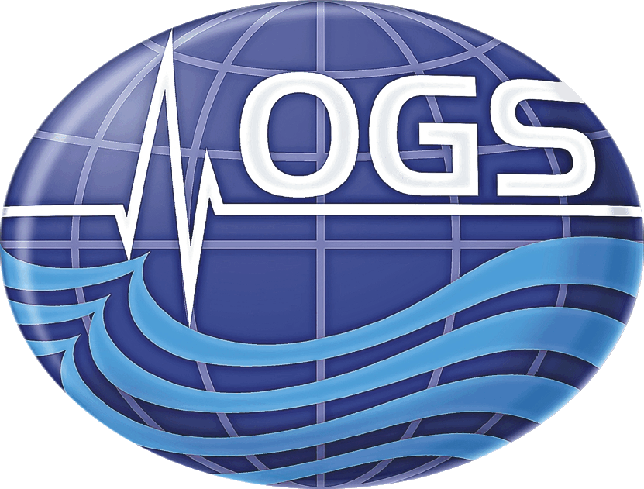

SEAGAS: an H2020 Marie Skłodowska-Curie Action to investigate gas hydrate systems on the Mediterranean and Brazilian margins

Daniel Praeg

The Marie Skłodowska-Curie Actions (MSCA) are EC-funded international fellowships that allow individual researchers to propose career-focused research and training projects, involving mobility within Europe and worldwide. SEAGAS is an MSCA Global Fellowship that will soon be taking the speaker for two years to Brazil (PUCRS, Porto Alegre), followed by a return year in France (Géoazur, Nice). The talk will: 1) explain the nature of MSCA individual fellowships (open to all, in all subjects); 2) outline the SEAGAS project, showing how it grew from OGS collaborations with French and Brazilian partners; and 3) discuss continued involvement via a proposed campaign of the OGS Explora.

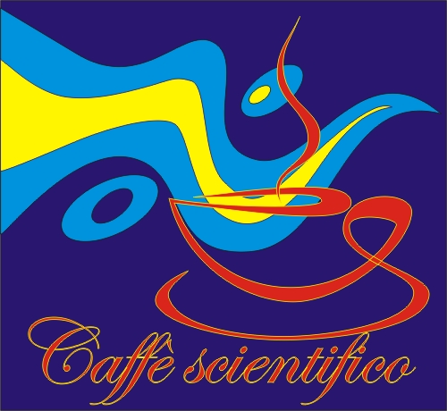

6 ottobre 2015 ore 11:00

Sala “Antonio Michelato”, palazzina “Ferruccio Mosetti” OGS, Borgo Grotta Gigante

http://nettuno.ogs.trieste.it/jungo/caffe_scientifico/

